3DGP final Project Report

Game : Defend penguins

0656124 劉承順

107/01/25



**Introduction**

Game Title :Defend penguins

Member List :劉承順

Game Type:Action-adventure game

Game platform:PC

OS: Windows

player Perspective (camera): third -person

**Contents**

1. Game Design
2. System Architecture
3. Techniques
4. Implementation items
5. SWOT
6. Conclusion

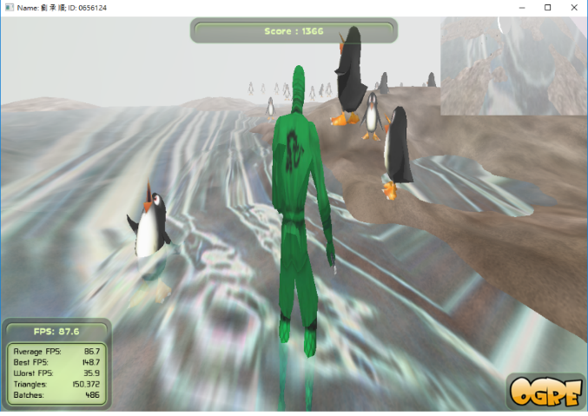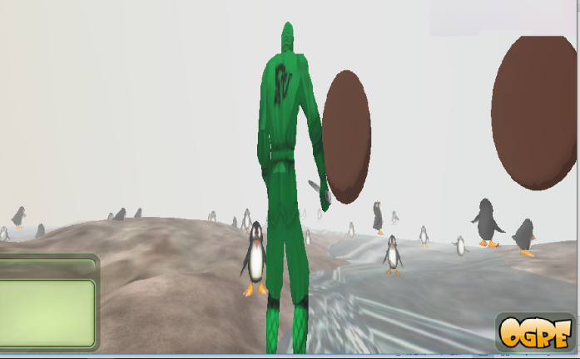**Representative images**

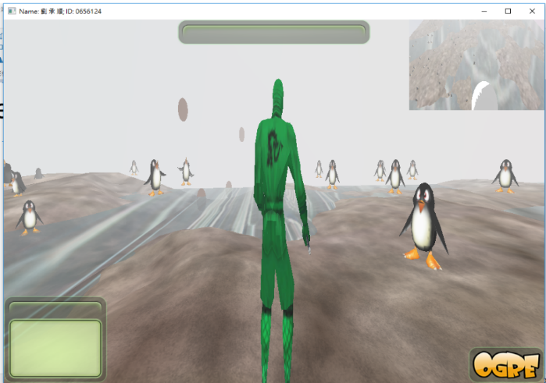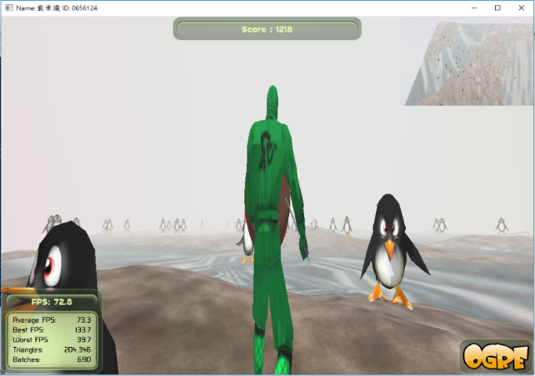

1. Game Design

1-1 Game Design - Game features

* A 3D shooting game.
* Penguins chasing you, attack them and

prepare their rush!

1-2 Game Design - Game story

A ninja, comes to thePenguin island. The weather is too hot, so penguins are angry. He wants to defend angry penguins.

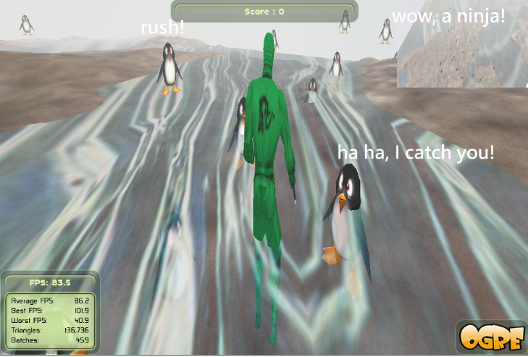

1-3 Game Design - Game goal

Travel the island.

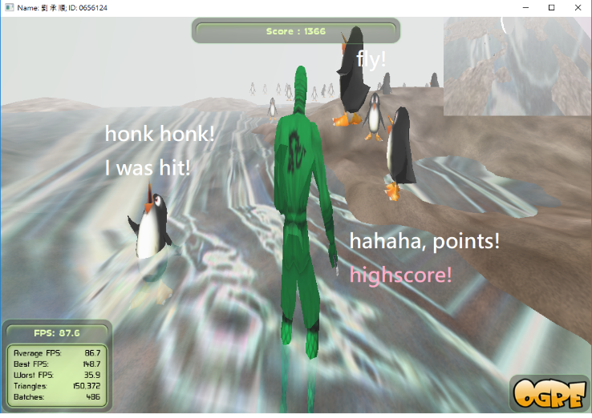

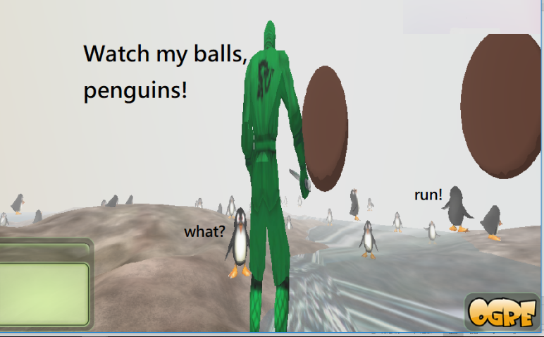1-4 Game Design - Game control

* W: go forward
* S: go backward
* Spacebar: shoot big ball
* Mouse: change direction

1-5 Game Design – Game level(s)

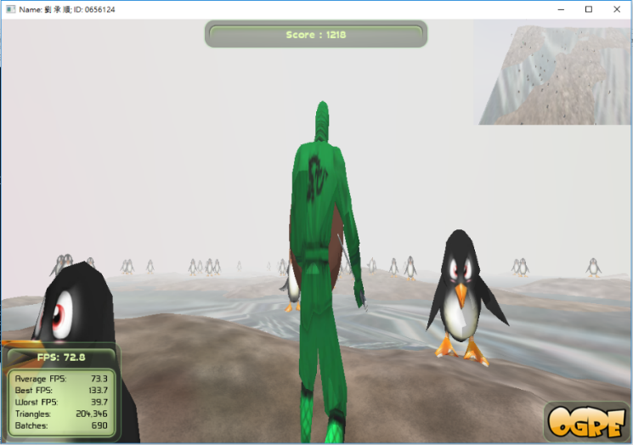If you hit a penguin, you get 100 point.

If you hit a shocked penguin, you get only 3 point.

Try as much point as you can!



2. System architecture

The follow hierarchy graph is the function and

files in my Visual C++ project.

1. Technical section

3-1 Ninja animation:

The ninja contains three kinds of animation: walk, idle, attack.

In mMainChar->update function, it has implemented the animation of ninja. Like this:

if (mWeaponMgr->mCoolDownTimeForFiring < 0.2){

mAnimationState = mEntity->getAnimationState("Kick");

mAnimationState->setLoop(true);

mAnimationState->setEnabled(true);

mAnimationState->addTime(5*evt.timeSinceLastFrame*sf);

}

3-2 penguin animation:

When the penguins are hit by bullet, they have “amuse” animation. It is implemented in “monster->update” ,which is called by “mostermanager->update”. And “mostermanager->update” is called in framestarted function.

if (hit){

mMonsterMgr->mMonstersArr[j]->die= true;

}

void MONSTER::update(const Ogre::FrameEvent& evt)

{

if (die){

dieTime = dieTime + evt.timeSinceLastEvent;

mAnimationState = mEntity->getAnimationState("amuse");

mAnimationState->setLoop(true);

mAnimationState->setEnabled(true);

mAnimationState->addTime(2*evt.timeSinceLastFrame);

if (dieTime >= 5){

dieTime=0;

die = false;

mAnimationState->setEnabled(false);

}

return;

}

….

}

3-3 Physics

3-3-1 Collision detect

In “mostermanager->update”, not only I called “monster->update”s, but also called Collision detect functions to deal with collisions between penguins- penguins and penguins-ninja. Bullet-big sphere collisions are detected in weaponmanager->update. Penguins – Bullet collisions are detected in framestarted like this :

for (int i = 0; i < w->mMaxNum; ++i) {

if (w->mUsedWeaponsArr[i] == false) continue;

WEAPON *g = w->mBulletsArr[i];

for (int j = 0; j < mMonsterMgr->mCurMonstersNum; ++j) {

if (!mMonsterMgr->mMonstersArr[j]->isAlive()) continue;

bool hit = g->hitTarget_Sphere( mMonsterMgr->mMonstersArr[j]->getPosition(), 60 );

if (hit){

…

}

}

};

3-3-2 Gravity

Balls have gravity and a little air resistence.

3-3-3 Terrain

The ninja walks on the main terrain.

Vector3 pos = mSceneNode->getPosition();

bool flg = projectScenePointOntoTerrain_PosDirection(pos);

if (flg == false) {

projectScenePointOntoTerrain_NegDirection(pos);

}

mSceneNode->setPosition(pos);

3-4 particle systems

When the penguins are hit by bullet, they can’t move for 5 seconds, and during this period, they are attached with particle systems on them.

First, I use function “initParticleSystemForExplosion()” to initialize particle system. In this function, I create particle nodes for each penguins.

In framestarted function, if a penguin was hit and become “die” status, I show the corresponding particle nodes of it. If it ends the “die” status, I make the particle node invisible.

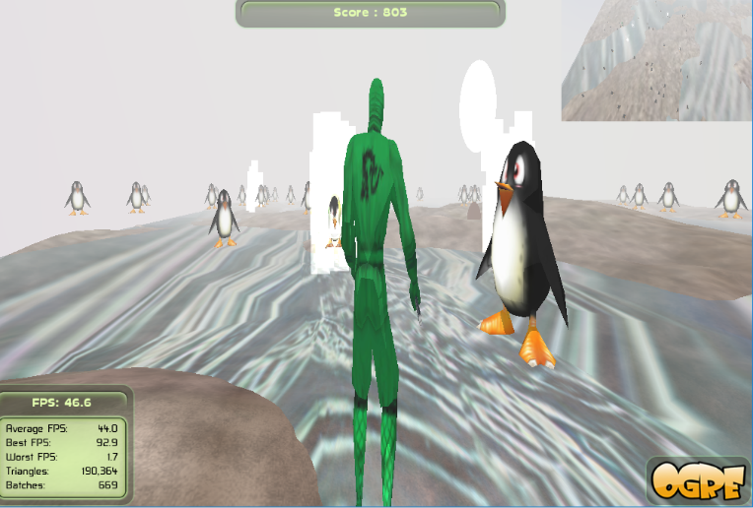

1. Contributions & Implementation items

* All the items that are implemented by each member

*me: idea, find information, coding, debug.*

* Contribution ratios

*100% me.*

* Work hours of each member

*about 20 hours for me.*

1. SWOT

|  |  |  |
| --- | --- | --- |
| Internal Enviroment | **Strength**  3D skills in Course such as physics、template of homeworks | **Weakness**  Completion, contents |
| External Enviroment | **Opportunities**  Simple to play and finish  3D scene | **Threats**  Other games have funny and clear feature. |

1. Conclusion

Ogre 3D is a 3D engine, but not a very convenient game engine. So I create a game based on the template of course homeworks.

It is a 3D game, we can explore the world by controlling the ninja.

My game have character animations, making them looked natural. The ninja fights the penguins, hope you enjoy the game, and get high score.